**EXERCISE 2.6**

1. **Find the values of the following by using logarithms.**

$\left(i\right)57.86×4.385$

$$SOLUTION$$

$57.86×4.385$

**STEP-1: Suppose X = $57.86×4.385$**

**X = $57.86×4.385$**

**STEP-2: Multiply Log on both sides**

$$\log{x}=\log{57.86 ×4.385}$$

$$\log{x}=\log{57.86+log 4.385}$$

**STEP-3: Check the value of log in calculator**

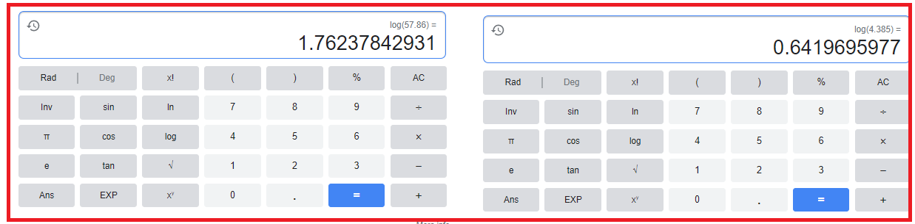

$$\log{x}=1.7624+0.9419=2.404$$

$$\log{x}=2.404$$

**STEP-4: Multiply Antilog on Both Sides**

$$Antilog*log{x}=Antilog 2.404$$

$$x=Antilog 2.404$$

**STEP-5: Check the value of Antilog in calculator**

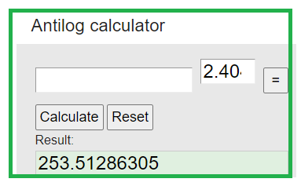

**STEP-1: Suppose X =**

**STEP-2: Multiply Log on both sides**

**STEP-3: Check the value of log in calculator**

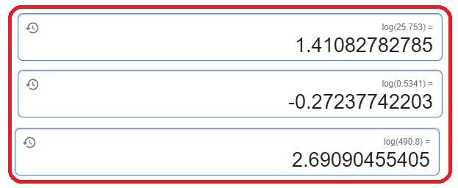

**STEP-4: Multiply Antilog on Both Sides**

**STEP-5: Check the value of Antilog in calculator**

**STEP-1: Suppose X =**

**STEP-2: Multiply Log on both sides**

**STEP-3: Check the value of log in calculator**

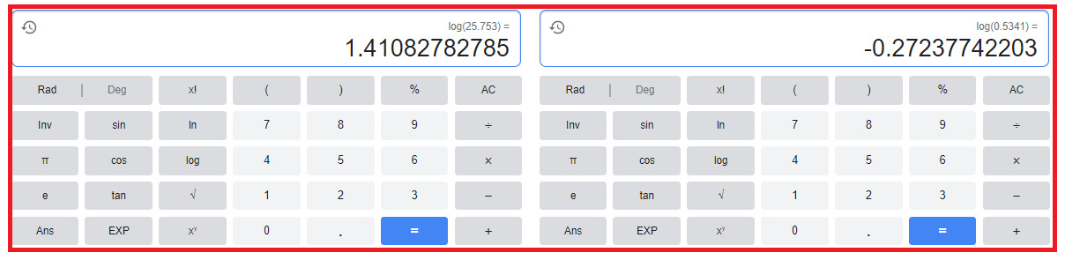

**STEP-4: Multiply Antilog on Both Sides**

**STEP-5: Check the value of Antilog in calculator**

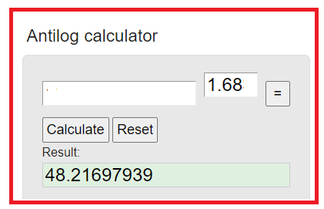

**STEP-1: Suppose X =**

**STEP-2: Multiply Log on both sides**

**STEP-3: Check the value of log in calculator**

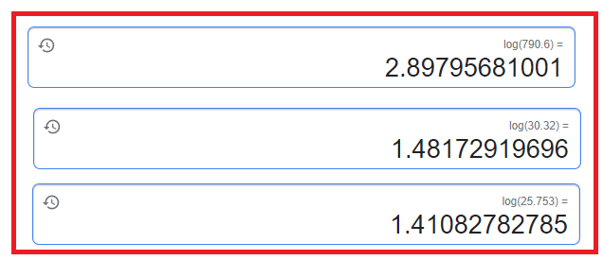

**STEP-4: Multiply Antilog on Both Sides**

**STEP-5: Check the value of Antilog in calculator**

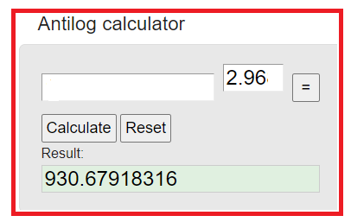

**STEP-1: Suppose X =**

**STEP-2: Multiply Log on both sides**

**STEP-3: Check the value of log in calculator**

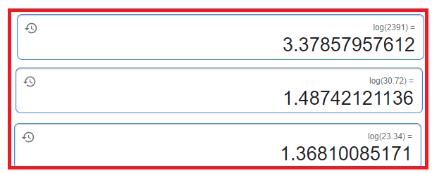

$$\log{x}=3.3786+1.4874 -1.3681$$

$$\log{x}=3.4979$$

**STEP-4: Multiply Antilog on Both Sides**

$$Antilog*log{x}=Antilog 3.4979$$

$$x=Antilog 3.4979$$

**STEP-5: Check the value of Antilog in calculator**

$$x=930.679---Answer$$



**EXERCISE 2.6**

**Q2. Find the number of digits in the following.**

1. **412**

**STEP-1: Suppose X =**

**STEP-2: Multiply Log on both sides**

**STEP-3: Check the value of log in calculator**

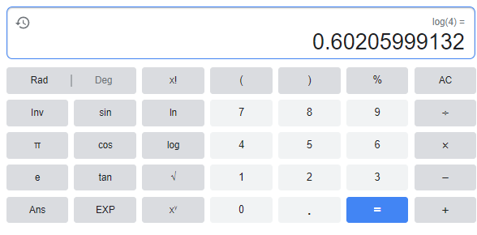

**STEP-4: Check Characteristics and add 1**

1. **752**

**STEP-1: Suppose X =**

**STEP-2: Multiply Log on both sides**

**STEP-3: Check the value of log in calculator**

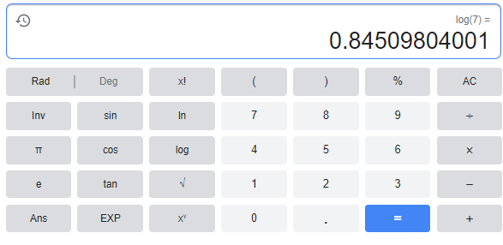

**STEP-4: Check Characteristics and add 1**

1. **330**

**STEP-1: Suppose X =**

**STEP-2: Multiply Log on both sides**

**STEP-3: Check the value of log in calculator**

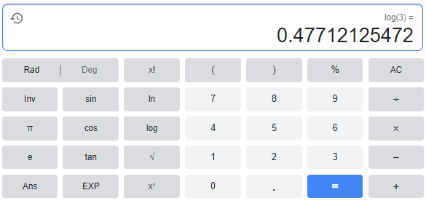

**STEP-4: Check Characteristics and add 1**

1. **35**

**STEP-1: Suppose X =**

**STEP-2: Multiply Log on both sides**

**STEP-3: Check the value of log in calculator**

**STEP-4: Check Characteristics and add 1**

1. **94**

**STEP-1: Suppose X =**

**STEP-2: Multiply Log on both sides**

**STEP-3: Check the value of log in calculator**

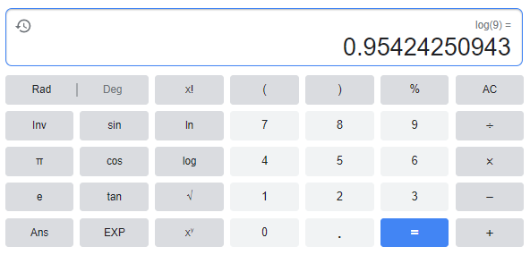

**STEP-4: Check Characteristics and add 1**